Directions to the showground

Warren Row Road, Knowl Hill, Maidenhead, RG10 9YT
From Maidenhead direction take the A4 towards Reading. As you enter Knowl Hill, take a right hand turn up Warren Row Road.

From Reading direction take the A4 towards Maidenhead. Just past the Royal Oak pub in Knowl Hill, take a left hand turn up Warren Row Road.

The Road is signposted towards Warren Row and Cockpole Green. Drive past the Showground on your right, and take the first right hand turn into the entrance.

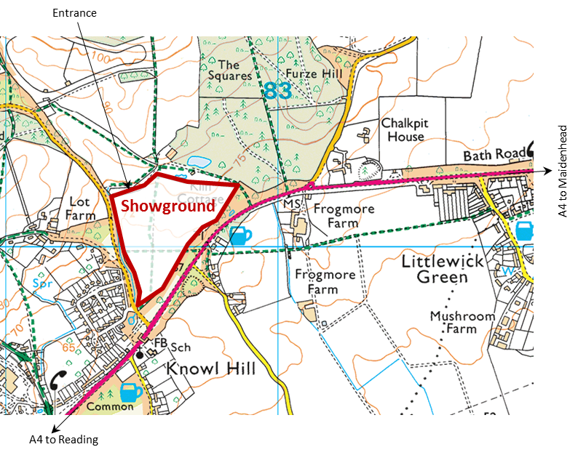

Please bring your own water for your horses, ponies and dogs.

Please ensure all your rubbish is taken home.

Thank you.

Littlewick Green Show Society
President: Mrs J. Distin

LITTLEWICK HORSE SHOW
2018

Bank Holiday Monday
27th August 2018




★ LOCATION 
Warren Row Road, Knowl Hill, Maidenhead
Postcode: RG10 9YT

www.littlewickshow.co.uk

Enter online at: www.equoevents.co.uk
Or post entries to: Show Secretary
Joydens, Manor Road, Maidenhead, Berks, SL6 2QG

 littlewickhorseshow@hotmail.co.uk  07766542500  @littlewickhorseshow
Organised by the
Littlewick Horse Show Committee:
Jill Oseman, Pam Teasdale,
Pam Swift, Barbara Donahue and Jo Burton

Entry Fees

Jumping Classes: £12.00 each except: Class 4 which is £10
Pairs Jumping: £18.00 per pair
Clear Round: £5.00 (at the ring side)
Showing Classes: £9.00 each
Gymkhana: £2.00 each (on the day)
First aid £4 per rider/handler

Late entries (after 24th August): £2.50 extra on each entry except for gymkhana and clear round where entries are on the day.

Two Phase Jumping:
If the competitor completes a clear round they will continue to jump off against the clock immediately.

Cups presented:
Class 6: Brookhart Cup
Class 8: Committee Trophy
Class 10: The Vigilante Challenge Cup
Class 12: Best Utility Pony Challenge Cup
Class 18: MacBride Cup
Class 35: Bunce Cup
Class 37: Cada Toys Challenge Trophy
Class 38: Battledore Challenge Trophy

NB. A £20 deposit will be required for all cups taken from the showground.

A plaque will be awarded to the winner of each class except Gymkhana.
Rosettes to 8th place.
Gymkhana rosettes to 4th place.

Catering
All day on-site catering.

Please note: All horse boxes and trailers plus their occupants will gain free access to the show. However, anyone arriving by car or on foot must pay the admission fee, even if accompanying a horsebox.

Information and Show Rules
It is the responsibility of the competitor to know the rules.

1. The decision of the organisers, judges & stewards will be final.
2. Although every effort is made to run the show to time, entry fees cannot be refunded when classes coincide.
3. The Committee reserves the right to move classes and/or rings as necessary.
4. Classes may be split or amalgamated at the judge’s discretion depending upon entries.
5. All jumping classes will be judged with reference to the rules of the BSJA. NOTE: riders are prohibited from remounting after a fall.
6. Entries in all classes will be strictly limited. Please note: classes may become full prior to the show date. Only if classes are not full will entries on the showground be accepted. Entries after 24th August £2.50 extra.
7. Rosettes will be awarded to 8th place, excluding gymkhana where rosettes will be given to 4th place.
8. LHSC, LGSS, the landowner, organisers and officials will accept no responsibility for any damage or injury that may occur to horse, rider, spectator or vehicle howsoever caused.
9. Correct riding attire and hard hats must be worn at all times whilst mounted anywhere on the showground. Acceptable hard hat standards are: PAS 015: 1998 or 2011 with BSI Kitemark, VG1 01.040: 2014-12 with BSI Kitemark, ASTM F1163: 2004a or 04a with SEI Mark, SNELL E2001 or E2016 and must have SNELL label and number, AS/NZS 3838: 2006 onwards with SAI Global Mark. Exceptions can be made for those entering Class 16 in traditional dress, a disclaimer must be signed in the Secretary’s tent.
10. All horses and ponies must be aged 4 years and over except in the in-hand classes.
11. Entry fees will only be refunded on production of a vet’s or doctor’s certificate.
12. First Aid will be provided on the show ground. The first aid charge of £4.00 applies equally to riders and handlers.
13. All enquiries should be made to the Horse Section Secretary’s tent.
14. All dogs must be kept on a lead and under control at all times.
15. Enquiries: Joanna Burton on 07766 542500.
Ring Three

Starts 09:00hrs
Please state breed on entry form for Mountain & Moorland classes.

Class 28: Mountain & Moorland: In Hand - Small Breeds
Welsh Sec A & B, Shetland, Dartmoor, Exmoor.
Open to registered and unregistered breeds of any age or sex.

Class 29: Mountain & Moorland: In Hand - Large Breeds
Welsh Sec C & D, Dales, Connemara, New Forest, Fell, Highland.
Open to registered and unregistered breeds of any age or sex.

Class 30: Coloured In Hand
Piebald, skewbald, tri-colour, palomino, dun, roan, cream or spotted. Open to horses/ponies any height or sex.

Not before 11:00hrs

Class 31: Veterans In Hand
Horses and ponies 17 years and over.

Class 32: Lead Rein
Open to any rider/horse/pony. Combination may not enter classes 11 or 13.

Not before 12:30hrs

Class 33: Mountain & Moorland: Ridden - Small Breeds
Welsh Sec A & B, Shetland, Dartmoor, Exmoor.
Open to registered and unregistered ponies of any age or sex.

Class 34: Mountain & Moorland: Ridden - Large Breeds
Welsh Sec C & D, Dales, Connemara, New Forest, Fell, Highland.
Open to registered and unregistered breeds of any age or sex.

Class 35: Ridden Veteran
Horses/ponies 17 years and over. No martingales or bandages/boots.
Cup: Bunce Cup

Class 36: Race Horse to Riding Horse

Class 37: Riding Club Horse
For horses exceeding 14.2hh. Judged on suitability for Riding Club activities. Snaffle bridles only. No boots, bandages or martingales. May be required to jump a small fence.
Cup: Cada Toys Challenge Trophy

Class 38: Riding Horse
For horses 15.2hh and over. Horses will not be required to jump.
Cup: Battledore Challenge Trophy
Main Ring
Starts 08:30hrs

Clear Round Jumping
Jumps up to 45cm. Entries at ringside £5. No pre-payment taken.

Starts 09:00hrs
Jackets must be worn
Class 1: Starters Jumping
Riders under 16 years old. Jumps up to 45cm in the first round. May be led.

Class 2: Minimus Jumping
Jumps up to 60cm in the first round. Riders entering this class may not take part in any other main ring classes, apart from classes 3 and 4. Cup for best turned out pony and rider.

Class 3: Novice Jumping (Two Phase)
Horses/ponies not to have been placed first in any jumping class before the day. Jumps up to 70cm in the first round.

Class 4: Horse and Hound
Horses/ponies/handlers & dogs to jump in relay against the clock.
Fences up to 45cm. Dogs may compete on or off the lead. Prize for best co-ordinated outfits!

To follow, if time until 14.00:
Clear Round Jumping
Jumps up to 80cm. Entries at ringside £5. No pre-payment taken.

Not before 14.00

Class 5: Top Score
Choose your own course to collect points. Jumps 60cm-1m.

Class 6: Local Jumping (Two Phase)
Horses/ponies kept within a 15 mile radius of the showground.
Jumps approximately 80cm in the first round.
Cup: Brookhart Cup

Class 7: Pairs Relay
Jumps approximately 80cm.
Class judged on time (no jump off).

Class 8: Open Intermediate Jumping (Two Phase)
Jumps approximately 85cm in the first round. Cup: Committee trophy
Ring Two

Starts 09:00hrs

Class 9: Best Condition
In Hand. Horses and ponies of any size or age.

Class 10: Tack and Turnout
Section A Show turnout (must be plaited)
Section B Hacking turnout
Cup: The Vigilante Challenge Cup

Class 11: First Pony
Ponies 13.2hh and under. To be judged on condition, presentation, turnout and character of pony. Combination may not enter Classes 13 or 32.

Class 12: Family Mount
Horse or pony suitable for all members of the family. Snaffle bridles only. No boots, bandages or martingales. Cup: Best Utility Pony Challenge Cup

Not before 11:00hrs

Class 13: Second Pony
Ponies over 13.2hh. Suitable for all pony club activities.
To be judged on condition, presentation, turnout and rider.
Combination may not enter Classes 11 or 32.

Class 14: Ridden Cob
Open to horses 14.2hh (148cm) or over.
Horses need not be hogged.

Class 15: Ridden Coloured
Piebald, skewbald, tri-colour, palomino, dun, roan, cream or spotted. Open to horses/ponies any height or sex.

Not before 13:00hrs

Class 16: Fancy Dress
Open to riders of any age. Horses/ponies may be ridden.
Riders must wear standard hats and suitable riding boots.
Equines must wear saddles.

Class 17: Foreign Breeds Ridden
Open to any foreign breed except warmbloods.
Traditional (see rule 9) or non-traditional dress.
Class will be split at judge’s discretion. Please state breed on entry form.
Ring Two continued

Class 18: Handy Pony
Open to any rider/horse combination.
To complete a course of obstacles and tasks,
to include one or more very small jumps.
Cup: The MacBride Cup

Not before 15:00hrs

Gymkhana

£1.00 per class.

All entries on the day from the Secretary’s tent. Competitors must wear approved riding hats (see rule 9) and footwear but need not wear show jackets.

Minimus section

All riders MUST be led. Competitors entering this section may not compete in any Open Gymkhana classes.

Class 19: Egg and spoon race
Class 20: Round the world
Class 21: Potato race
Class 22: Musical cups

Open section

Class 23: Egg and spoon race
Class 24: Potato race
Class 25: Canter, trot, walk
Class 26: Bucket elimination
Class 27: Musical cups

Millwheel Tack Shop & G.G. Feeds

Our equipment and feed always comes first...

- Top brands.
- Horse feed and bedding (including delivery service).
- Extended second-hand department, offering everything from jodhpur boots to saddles.
- Master saddler who will fit any saddle whether new or second-hand and take on any saddlery or tack repairs.
- Rugs washed and repaired
- Clippers serviced/blades sharpened.
And all at very competitive prices

Tel: 01344 486059 Mob: 07973 637629
saradodwell@outlook.com
Millwheel Tack Shop & G.G. Feeds
Moss End Garden Centre
Maidenhead Road
Warfield
Berkshire RG42 6EJ

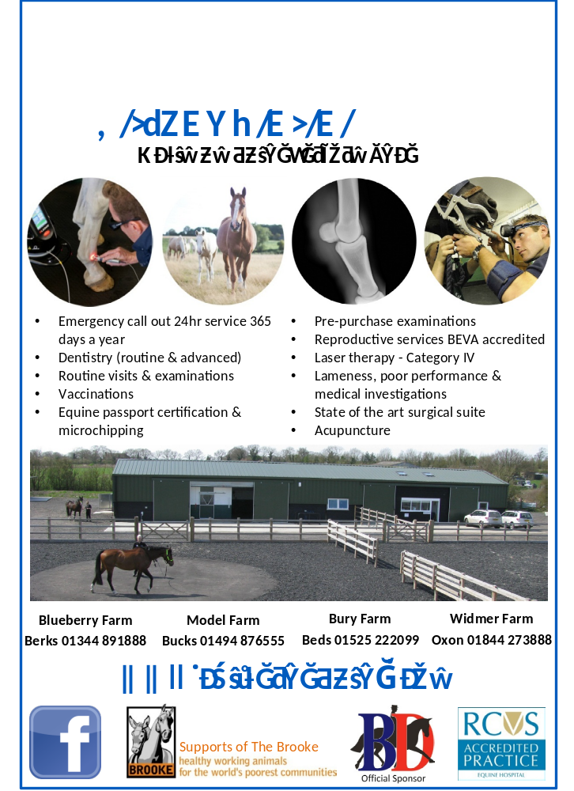
Horse Show
to be held at
Littlewick Show, Warren Row Road, Knowl Hill, Maidenhead, RG10 9YT
on Bank Holiday Monday, 27th August 2018

Entries to: Entries Secretary, Joydens,
Manor Road, Maidenhead, Berks, SL6 2QG

Name:

Address:

Post code:

Telephone: |  | Mobile: |  | Email:
Would you like us to email you next year’s schedule? Yes / No
Contact in case of emergency:

I agree to abide by the rules and conditions as set out in the schedule (must be signed by a parent or guardian if under the age of 18)

Signature:

Class | Name of rider/handler |  | Name of horse |  | Fee
 |  |  | Total |  | £
 |  |  | First aid per rider/handler £4 |  | £
 |  |  | Total |  | £
Classes 16, 28, 29, 33 and 34: Breed:

To avoid late entry charges, please enter on or before 24th August.

Cheques to be made payable to: ‘Littlewick Horse Show Committee’.

You can now enter online at:
www.equoevents.co.uk/ViewEvent/ViewEventDetails/18221
Please note there is £1.50 booking fee for online entries.

Please note: All horse boxes and trailers, plus their occupants will gain free access to the show. However, anyone arriving by car or by foot must pay the admission fee, even if accompanying a horsebox.

